Forecasting Assignment
For this week’s assignment on forecasting we are to:
1. Complete the AI futures survey
https://jh.qualtrics.com/jfe/form/SV_1MJJuhRrUAMA8L4
Your answers should be visible to you after you submit, but you might also want to take notes.
2. Read the Future survey paper and comment on differences between your forecasts and the AI experts.
3. Comment on your interpretation and process for making these forecasts questions.
4. Describe a most detailed process for one forecast that includes some elements of Tetlock's CHAMPS KNOW method (whatever is appropriate).

1. Complete the AI Futures Survey
Answers attached.

2. Read the survey paper and comment on differences between your forecasts and the AI experts
It seems I was only given part of the survey because I started from the beginning and proceeded question by question until I reached the end (where my answers were summarized and downloadable) and I only encountered questions on HLMI (defined later). But contrasting my answers with the results of the survey in this regard is possible. The paper mentions:
“In both 2022 and 2023, respondents gave a wide range of predictions for how soon HLMI will be feasible (Figure 3). The aggregate 2023 forecast predicted a 50% chance of HLMI by 2047, down thirteen years from 2060 in the 2022 survey. For comparison, in the six years between the 2016 and 2022 surveys, the expected date moved only one year earlier, from 2061 to 20601. The aggregate 2023 forecast predicted a 10% chance of HLMI by 2027, down two years from 2029 in the 2022 survey.”

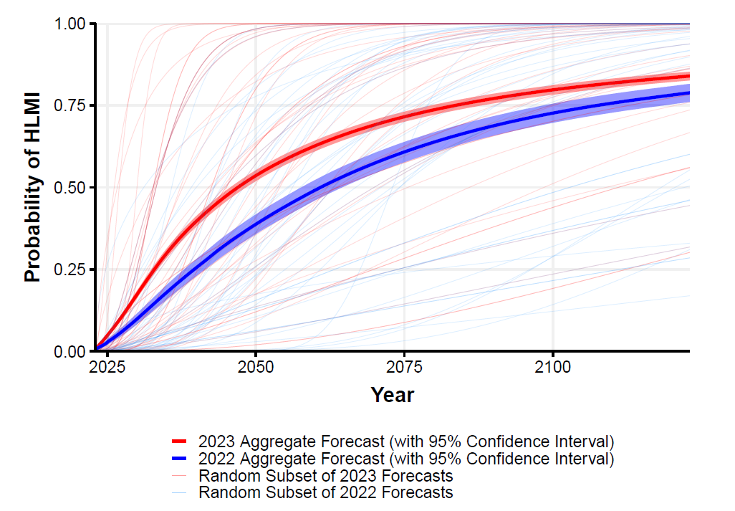
The relevant part of Figure 3.
My predictions were much more pessimistic than the experts, mostly due to my concern over sufficiently efficient, reliable and fast robotics, not AI. No discussion was made about the optional responses, or factors that led to a respondents forecasts, so it is impossible to compare and contrast my method with that of other respondents. That would be difficult to summarize.

3. Comment on your interpretation and process for making these forecasts questions.
The process behind the creation of these questions seems to be a focus on standardization and psychology. The questions leave out many important nuances so it’s difficult to see why respondents disagreed. Also there is a lot of discussion about framing effects, so there is a consideration of cognitive bias. At the heart of the report is a methodology centered on soliciting predictions about AI's progress from researchers who have recently contributed to top-tier AI venues. This approach, while leveraging the expertise of those at the forefront of AI, may introduce biases reflective of the current research focus and technological priorities. It's imperative to recognize the selection bias in the tasks and milestones chosen for prediction, as they may overlook domains of AI application that hold significant potential for impact.

The report also sheds light on the demographic and geographical variations among respondents, revealing differences in expectations that could underscore culturally influenced biases or differing levels of optimism. Such variations emphasize the need for a globally coordinated approach to AI development and governance, ensuring diverse perspectives are considered in shaping the future of AI.
Notably, the survey delves into the potential for extremely bad outcomes, including existential risks posed by AI. This acknowledgment aligns with current ethical debates in AI, underscoring the critical need for prioritizing AI safety research and alignment efforts. The responses indicating a split opinion on the desirability of faster versus slower AI progress further complicate the governance landscape. This division calls for nuanced policy approaches that can adapt to the complex dynamics of AI development, balancing innovation with safety and ethical considerations.
Comparing shifts in expectations with previous surveys offers a lens through which to observe how expert opinions evolve alongside AI advancements and public discourse. Such analysis can identify trends that may inform policy, research prioritization, and the broader understanding of AI's societal implications. However, the survey's methodology is not without its limitations. The potential biases introduced by the sampling method, response rate, and question framing warrant a cautious interpretation of the results. These factors highlight the need for ongoing research and diverse data collection efforts to build a more holistic understanding of AI's future trajectory.

4. Using CHAMPS KNOW to Forecast HLMI

The question I am selecting is the first one:
HLMI.
The following questions ask about ‘high–level machine intelligence’ (HLMI). 1 of 7 Say we have ‘high-level machine intelligence’ when unaided machines can accomplish every task better and more cheaply than human workers. Ignore aspects of tasks for which being a human is intrinsically advantageous, e.g. being accepted as a jury member. Think feasibility, not adoption.
For the purposes of this question, assume that human scientific activity continues without major negative disruption.
How likely is it that HLMI exists: in 10 years? In 20 years? In 40 years?

Philip Tetlock's approach to forecasting emphasizes the importance of breaking down complex questions into smaller, more manageable parts and evaluating each component. This methodological approach is rooted in the idea that careful analysis, the aggregation of diverse perspectives, and the iterative refinement of predictions can significantly improve forecasts. Tetlock highlights the value of probabilistic thinking, encouraging forecasters to express their confidence in various outcomes as probabilities rather than certainties. This encourages a mindset that is both flexible and nuanced, acknowledging the inherent uncertainties in predicting future events. The CHAMPS KNOW framework, is Tetlock’s philosophy, advocating for a structured, analytical approach to dissecting and understanding the barriers and opportunities that lie ahead. Applied to forecasting the development of human-level machine intelligence (HLMI), and shooting from the hip, my forecast that the development of HLMI within X years is:
10 years: 5% - a possible outcome
20 years: 25% - a solid chance
40 years: 60% - likely
These figures mostly apprehend the challenges in Robotics, not AI. However the question mentions machine intelligence defined to include that, but which I take to not include physical agency. So if we considered intelligence as only a conceptual construct my guesses would be much higher: 60%, 80% and 95%. In my view machines will be able to comprehend all tasks sooner than they can perform them on a human level with the same reliability and speed. I think we are already seeing this trend, although there have been recent advances in the training of trajectories in virtual environments that may obviate my predications if they are developed fully. There is this certain divide in the formulation of these challenges in academia and industry today. Robotics and AI are mainly two different departments. Given this is an AI class not a robotics class I will bifurcate the inquiry and only address AI, the conceptual aspect of HLMI, which means my answers should be taken to be 60%, 80%, and 95%.
But to create a supporting forecast on the probability of developing human-level machine intelligence as I define it over these different time horizons using Philip Tetlock's CHAMPS KNOW approach, we first need to delve into the factors that could influence the development of such HLMI. Let's break down the possible key elements of forecasting a more conceptual HLMI development, and outline an inquiry approach tailored to each aspect of the CHAMPS KNOW framework.

Factors Relevant to Conceptual HLMI Development
1. Technological Advances: Progress in algorithms, computing power, and data availability.
2. Research Funding and Investment: The level of public and private investment in AI research.
3. Ethical and Regulatory Frameworks: How societies navigate the ethical implications and establish regulations.
4. Global Collaboration and Competition: The extent of international cooperation versus rivalry in AI advancement.
5. Breakthroughs in Neuroscience: Understanding human intelligence can guide HLMI development.
6. Adoption and Integration: The rate at which AI is incorporated into various sectors.
7. Public Perception and Social Impact: Societal acceptance and the broader impacts of HLMI on employment and privacy.
How would these considerations fit into the CHAMPS KNOW framework? Let’s consider:

CHAMPS KNOW Approach
These are the parts of Tetlock’s approach in the context of our question:

- C - Challenges: Identify the most significant technological, ethical, and societal challenges in achieving HLMI.
- H - Heterogeneity: Acknowledge the diversity in AI development paths and potential roadblocks or accelerators.
- A - Autonomy: Consider how advancements in autonomous systems and learning algorithms contribute to HLMI.
- M - Models: Examine existing models and theories of human cognition and AI to guide development forecasts.
- P - Predictions: Gather and analyze predictions from leading AI researchers, institutions, and historical trends.
- S - Synthesizing: Synthesize insights from the above aspects to form a coherent outlook on HLMI development.

- K - Knowns: List what is currently understood about AI capabilities, limitations, and the trajectory of progress.
- N - News: Stay updated with the latest AI breakthroughs, policy changes, and global AI initiatives.
- O - Opinions: Include expert opinions, especially those with a track record of accurate technology forecasts.
- W - Wildcards: Identify and assess potential wildcard events that could dramatically alter the pace of HLMI development (e.g., major breakthroughs in quantum computing or neuroscience).

This approach emphasizes a structured, comprehensive exploration of the factors and forces shaping the future of AI, leveraging the CHAMPS KNOW framework to guide a systematic inquiry into HLMI development probabilities. A more robust approach would delineate some scenarios and synthesize them, enumerate unknowns and uncertainties, formulate a formal model, and make a more educated guess, but under the constraints of the assignment we will make a more concise treatment based on Tetlock’s ideas. Let’s proceed letter by letter. The "CHAMPS" part of the framework is designed to dissect the challenge at hand into more manageable pieces, focusing on different dimensions of the issue:

C - Challenges
The development of human-level machine intelligence (HLMI) faces a myriad of challenges, both technical and societal. Technically, creating algorithms that can replicate or surpass human cognitive abilities in a broad range of tasks is a formidable challenge. This includes developing AI that possesses general intelligence, creativity, emotional understanding, and the ability to learn in unstructured environments among others—qualities that are inherently human. On the societal front, ethical considerations, such as privacy, security, and the potential for job displacement, pose significant challenges. Additionally, establishing global regulations and standards for the development and deployment of such technologies is complex, given the diverse interests and values across different cultures and nations. This plethora of challenges should give us some doubt that it can be accomplished at all, or within the given timeframes. This skepticism should be mitigated by the motivation and concerted effort we are seeing in the race to develop HLMI. The technical challenges are becoming more known and solutions are cropping up piece by piece. We should also remember that these may be solved before important social protections in ethics, security, or governance are secured. Indeed, it is the pattern of man to usually wait until problems arise with technology before imposing constraints. Problems aren’t usually solved until they arise. This lends me to feel the challenges we should consider are mostly technical. The question is when will HLMI be developed, not when it is successfully implemented safely.
A more detailed analysis would Investigate the current state of AI in terms of its capabilities in natural language understanding, problem-solving, and learning efficiency compared to human benchmarks. Focus on the limitations of current AI systems in understanding context, generalizing knowledge across domains, and acquiring knowledge from limited data, would be key challenges.

H - Heterogeneity
The path to HLMI is not homogeneous; it encompasses a variety of approaches, methodologies, and philosophies. From symbolic AI to neural networks and from reinforcement learning to hybrid models, the diversity in AI research reflects the complexity of mimicking human intelligence. This heterogeneity is both a strength and a challenge. It's a strength because it allows for multiple pathways to potential breakthroughs; it's a challenge because it complicates the ability to coordinate efforts and build cumulative knowledge. Here, I find the heterogeneity falls on the plus side of our forecast, providing more ways to be successful.
A more robust analysis would examine the different branches of AI research and development, identifying the strengths and weaknesses of each approach. We should pay particular attention to emerging paradigms that might offer new paths to achieving general intelligence. One way would be to analyze case studies or research papers that demonstrate successful integration of heterogeneous AI systems, highlighting how these integrations overcome the limitations of individual approaches.

A - Autonomy
Achieving autonomy in AI systems—whereby they can operate and make decisions in complex, unstructured environments without human intervention—is crucial for HLMI. This involves not only advanced decision-making capabilities but also the ability for machines to understand and adapt to their environments in ways similar to humans. This level of autonomy requires significant advancements in perception, cognitive flexibility, and adaptability.
In the context of developing HLMI, autonomy not only refers to the capabilities of AI systems but also to the research process itself. AI research largely operates autonomously from oversight bodies, as comprehensive regulatory frameworks specific to AI development are yet to be established. This relative freedom allows for rapid innovation and exploration of various methodologies. However, it also raises concerns about the ethical implications of AI research and the potential consequences of deploying advanced AI systems without sufficient oversight. The balance between fostering innovation and ensuring responsible development is a critical challenge for the field. I think this consideration is most important, as the former is a technical challenge, and so let’s consider the autonomy criteria met.
To evaluate the technical challenge, we should research the current advancements in autonomous systems, focusing on areas such as robotics, autonomous vehicles, and unmanned aerial vehicles (UAVs). Identifying the technologies driving these advancements and the challenges they face in achieving full autonomy would be a start. We could also explore the concept of machine learning algorithms that can adapt their learning strategies based on the environment, akin to human learning. Investigate how these adaptive algorithms are being developed and tested in various domains.
Then it would be to investigate the current state of governance and oversight in AI research. This involves examining the role of existing ethical guidelines, professional codes of conduct, and any regulatory bodies that influence AI development. We should explore debates and proposals around the creation of more robust oversight mechanisms that can keep pace with the rapid advancements in AI technology, or might hinder it.

M - Models
In the quest for HLMI, the development and refinement of computational models that can mimic or surpass human cognitive processes are central. This involves drawing from and contributing to various fields such as cognitive science, neuroscience, computer science, and mathematics. The diversity of models—from symbolic AI, which focuses on logic and rules, to connectionist models like neural networks that simulate brain functions—reflects the complexity of human intelligence. Understanding and integrating these models to create systems that exhibit general intelligence, emotional understanding, and creative problem-solving is a significant challenge but is one we should undertake for a complete forecast.
To do this we should review comparative studies into different AI models, focusing on their abilities to replicate aspects of human cognition, such as learning, memory, and problem-solving. Paying special attention to interdisciplinary research that combines insights from neuroscience, cognitive science, and AI would be fruitful. Further, we must investigate integrative approaches by exploring research on integrative models that combine the strengths Then we would look into different AI approaches (e.g., hybrid models that merge symbolic AI with neural networks), and analyze how these models address the limitations of individual approaches and what they reveal about the path to achieving HLMI. That there are these models show that we are on the path to HLMI.
A proper forecast would incorporate a prediction model for forecasting the level and progress of technological development in AI towards HLMI offers a pragmatic approach to gauging future advancements. This type of model, while not deeply nuanced, can provide a baseline understanding and highlight trends based on available data. For such a model, we might consider a simplified extrapolation method that uses historical data on key indicators of AI progress (such as computational power, algorithm efficiency, and milestones in AI capabilities) to project future trends. To this end I present three key graphs representing the progress in each. Rather than choosing some arbitrary weights and making a model, I leave it to you to make up your own mind, Presumably a complete forecast would look deeper and make such an attempt, after some years of research. An even better model would have to:
1. Define Key Indicators: Identify measurable indicators of AI development that are consistently tracked over time. These could include metrics like the number of AI research papers published, advancements in computational power (e.g., FLOPS), milestones in natural language processing and image recognition, and the amount of investment in AI research.
2. Gather Historical Data: Look for sources of historical data on these indicators. Academic databases, AI research institution reports, industry whitepapers, and tech industry investment trends are potential goldmines. Websites of organizations like the Association for the Advancement of Artificial Intelligence (AAAI) or the IEEE that might host relevant datasets.
3. Construct an Extrapolation Model: Using tools like Python's Pandas for data manipulation and SciPy or StatsModels for simple linear regression or more complex models if necessary, it would construct a model that fits the historical data and projects future trends. We must keep in mind that this model's accuracy will be limited by the linearity assumption and the inherent unpredictability of technological breakthroughs, so transformation may also be appropriate.

4. Refine With Expert Input: Enhancing our model's assumptions by incorporating insights from expert predictions and significant known factors (e.g., Moore's Law for computational power growth, or known investment trends). This can help adjust for non-linearities and anticipated shifts in development trends.
5. Continuous Updating: Plan for regular updates to the model as new data becomes available. Technological development is not only rapid but can be significantly influenced by breakthroughs, policy changes, and global economic factors.

I considered putting together a multiple linear regression on the variables of computational power, investment in AI, and AI research output overlaid over milestone achievements in AI as a way to create some kind of view into the future, but given the inherently subjective nature of the question posed (and the absence of a clear threshold), I decided that considering each of these separately in turn would be more informative than some model with contrived weights. Here are four charts we can take as indicators of trend:
The first shows the explosion in compute and is from The Visual Capitalist at:

Charted: The Exponential Growth in AI Computation (visualcapitalist.com)

The second shows the growth in AI investment and is from IEEE’s State of AI 2023 report:

State of AI in 2023

The third/fourth show the explosion of LLM development, and are from Medium at:

LLMs Timeline: Closed Source vs. Open Source

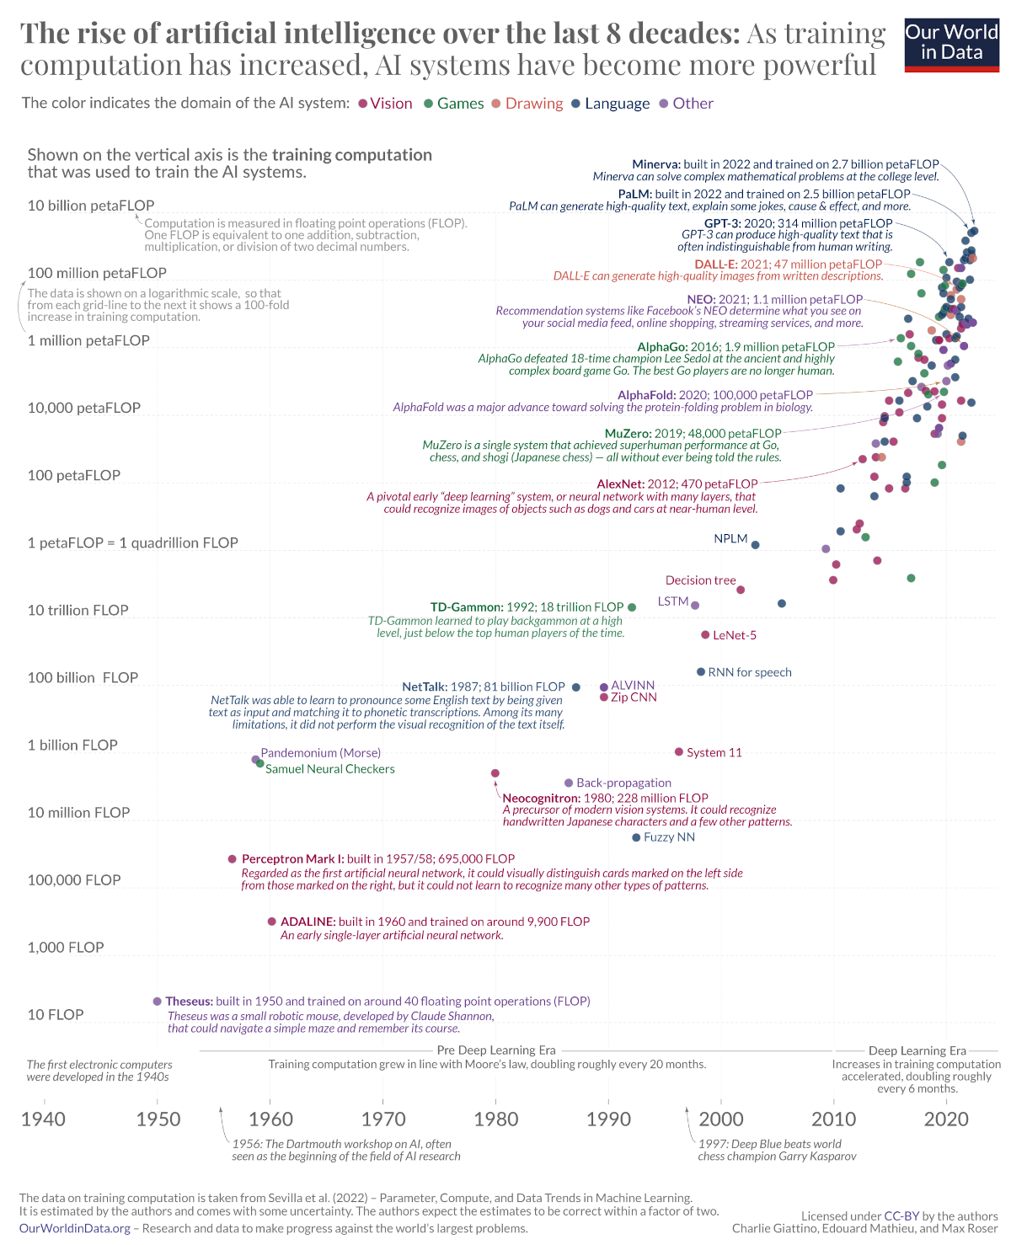

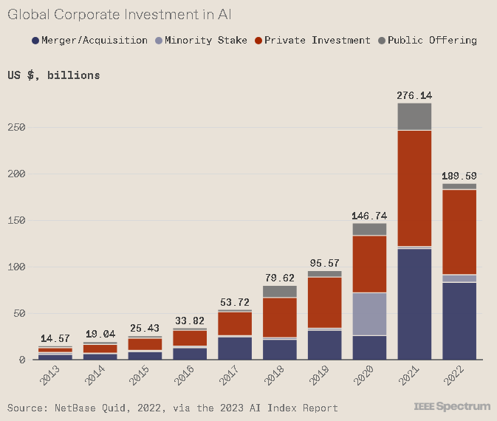

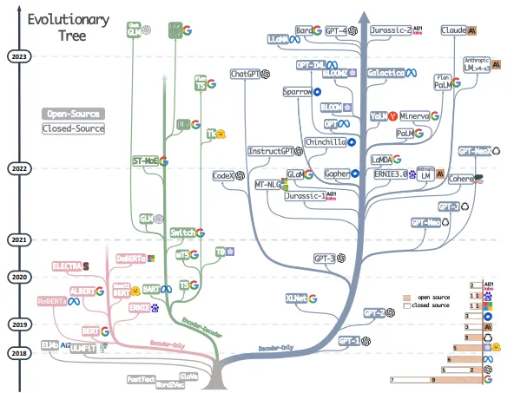
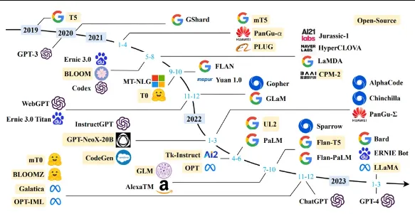
I think without taking on the challenge of a formal model, with it’s inherent subjectivity and uncertainty, it is more useful to look at these charts and note that compute, investment (recent reversion aside), and research effort appears to be increasing exponentially for now.
P - Predictions
Forecasting the timeline for achieving HLMI involves synthesizing predictions from a wide range of experts and disciplines. These predictions are influenced by current technological capabilities, anticipated breakthroughs, and the global landscape of AI research and development. While there's considerable variation in these predictions, analyzing them can provide valuable insights into the consensus areas and the points of contention among experts. I am unable to properly do this within the constraints here, but the aggregate forecast results of the survey should suffice. As represented in their Figure 3:
10 years: about 30%
20 years: about 45%
40 years: about 70%
A complete treatment would:
1.Gather Expert Predictions: Compile predictions from leading AI researchers, industry leaders, and academic institutions regarding the timeline for achieving HLMI. Note the rationales behind these predictions and any assumptions they make about technological advancements or societal developments.
2. Analyze Trends in Predictions: Identify trends in these predictions over time, considering how changes in technology, policy, and global events have influenced expert opinions. Explore whether there's a convergence towards a narrower range of timelines or if predictions remain widely divergent.

S – Synthesizing
Synthesizing insights from the challenges, heterogeneity, autonomy, models, and predictions related to HLMI requires a comprehensive and nuanced approach. This involves not only aggregating data and opinions but also critically evaluating the quality of evidence and the plausibility of different scenarios. Synthesizing these insights can help to form a balanced perspective on the potential timelines for achieving HLMI, taking into account technological, societal, and ethical dimensions. I really can’t do that here, but a full report would:
1. Develop a Synthesis Framework: Create a framework for synthesizing insights from diverse sources, considering factors such as technological feasibility, societal readiness, ethical considerations, and global cooperation. This framework should allow for weighting different types of evidence and assessing the impact of uncertainties.
2. Apply the Framework: Use the framework to integrate and analyze the information gathered from the CHAMPS sections. This should culminate in a set of scenarios reflecting different paths to HLMI, along with an evaluation of their likelihood based on the synthesized insights.
For this element I will just look on the back of the envelope and venture that the balance of these considerations noted so far is towards the eventual success of research efforts on the technical side. And now for the second half of the forecast. The "KNOW" part emphasizes the importance of continuous learning and adaptation in forecasting:

K - Knowns
In the context of forecasting the development of HLMI, it's crucial to start with what is concretely known about current AI capabilities, limitations, and the broader trajectory of AI research and development. This includes understanding the state-of-the-art in machine learning, neural networks, computational power, and data availability. It also involves recognizing the current societal and ethical landscape of AI, including public perception, regulatory frameworks, and the economic and social implications of AI advancements. We’ve touched on some of these points, but a better look would:
1. Catalog Current AI Capabilities: Compile a list of recent achievements in AI across various domains such as language processing, image recognition, and autonomous navigation. This could involve reviewing papers from top AI conferences like NeurIPS, ICML, and CVPR.
2. Identify Limitations: Research the limitations of current AI systems, focusing on areas where human performance significantly surpasses AI, such as generalizability, reasoning under uncertainty, and creative problem-solving.
3. Monitor AI Trajectory: Follow the progress of AI through technology news platforms, AI research publication databases, and announcements from leading AI research labs and companies.

N - News
Staying abreast of the latest developments in AI research, policy changes, and significant investments in the AI field is essential for updating and refining the forecast for HLMI. The AI landscape evolves rapidly, with breakthroughs, setbacks, and new ethical and regulatory considerations emerging regularly. Tracking these developments can provide insights into the pace and direction of progress towards HLMI. I subscribe to three newsletters, and reading them all every week is a challenge, so much is happening. Compiling and gaining insights from those sources and other news is impossible here, but we should:
1. Set Up News Alerts: Use tools like Google Alerts with keywords related to AI breakthroughs, AI ethics, AI regulation, and specific technologies or companies at the forefront of AI research.
2. Follow Key Organizations and Journals: Keep tabs on publications and announcements from leading AI research institutions, technology companies, and academic journals.
3. Engage with the AI Community: Participate in AI forums, social media groups, and attend conferences or webinars to hear discussions on the latest AI developments and perspectives.

O – Opinions
Expert opinions, especially from those with a track record of accurate predictions in technology fields, are invaluable for forecasting the development of HLMI. These opinions can provide insight into emerging trends, potential breakthroughs, and the challenges that lie ahead. However, it's important to critically evaluate these opinions, considering the experts' biases, the basis of their predictions, and how their views fit with broader trends. Opinions differ on the topic of HLMI, but for this section we will just note the survey results above. A total view would:
1. Survey Expert Predictions: Collect and analyze opinions from leading AI researchers, technologists, and industry analysts on the timeline and challenges for achieving HLMI.
2. Evaluate Opinions: Assess the credibility of these opinions based on the experts' experience, track record, and the reasoning behind their predictions.
3. Compare Diverse Views: Look for areas of consensus and divergence among experts to understand the range of possible outcomes for the development of HLMI.

W - Wildcards
Wildcards are unexpected events or breakthroughs that could significantly accelerate or derail the progress towards HLMI, like breakthroughs, accidents or black swans. This could include major advancements in quantum computing, discoveries in neuroscience that offer new models for AI, or global events that shift the focus and resources away from AI research. A lot of thought should be put into hypotheticals here by:
1. Identifying Potential Wildcards: Research historical precedents where unexpected breakthroughs or events have radically shifted technological trajectories. Use these as a basis to brainstorm potential wildcards in the AI field.
2. Assessing Impact: For each identified wildcard, evaluate its potential impact on the development of HLMI. Consider both positive accelerations and negative disruptions.
3. Incorporating them into Scenarios: Include wildcards in our forecasting scenarios, considering how they could change the likelihood of different outcomes.

The KNOW framework segment provides a structured approach to gather, evaluate, and incorporate a broad range of inputs into our forecast for the development of HLMI. By systematically addressing each of these areas, we can create a more informed and nuanced forecast. Unfortunately my treatment here yields more questions than answers, or even hypotheses, but given the monumental nature of the task I think I have presented at least a good roadmap and a path towards an educated guess.

